Healthcare Analytics Lakehouse
- Started with data generation with the help of AI. Not able to find a reliable dataset and source.
- Step 0 includes data generation using python and split the data into five set. Then using these five set as different data source system.
- Source-system overview
Source | System | Entities | Interface | Load type
EHR | Hospital EHR / ADT | patient, encounter, admission, discharge, bed_assignment, diagnosis, procedure | SQL Server | Incremental
SCHED | Appointment scheduling | appointment, appointment_status_history, clinic_slot | Azure SQL + change tracking | Incremental
LIS | Laboratory information system | lab_order, lab_result, specimen | HL7 v2 / flat file | Incremental
PHARM | Pharmacy | medication_order, dispense, formulary | REST API | Incremental
CLAIMS | Insurance platform | claim_header, claim_line, adjudication, payer | EDI 837/835 over SFTP | Daily
FIN | Billing / ERP | invoice, invoice_line, payment, adjustment | Oracle | Daily
HR | Staffing | doctor, staff, department_assignment, credential | CSV export | Daily snapshot
SURVEY | Patient satisfaction | survey_response, survey_question | SaaS API | Daily
FACIL | Facility management | hospital, department, ward, room, bed | CSV export | Daily snapshot
REF | Reference vocabularies | ICD-10-CA, LOINC, DIN/ATC, CCI | Manual upload | Quarterly

- Created 4 lakehouse [LH_Bronze, LH_Silver, LH_Gold, LH_Governance]
- 1 warehouse
- Step 1: Data Ingestion | Source SQLServer
DBO: EHR | SCHED | FIN
Pipeline: plIngestSQL
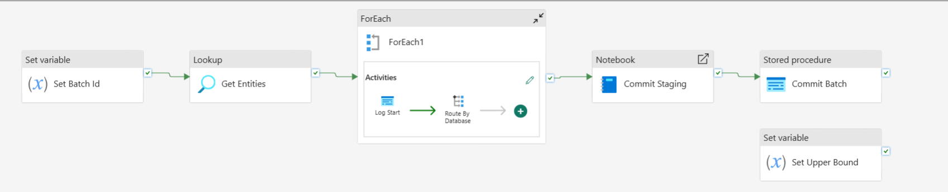
- Set Batch ID (setVariable) for assigning batchID for a particular run and appended as a column in the dataset.
- Set Upper Bound (setVariable) for assing watermark value to utcNow .
- Get Entities (Lookup) using stored procedure to get entities(table names) and pass on to forEach.
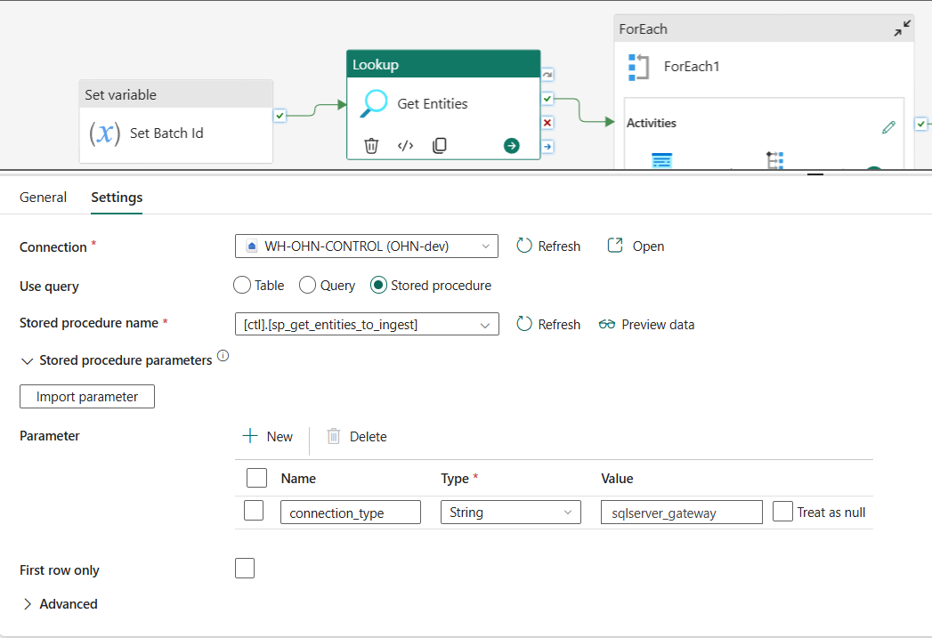
- This will get 11 entities
  - EHR: Admission | Bed_Assignment | Diagnosis | Emergency_Visist | Patient
  - FIN: Invoice | Invoice_line | Patient_Account
  - Sched: Apoointment | appointment_status_history | Patient
- ForEach:
  - 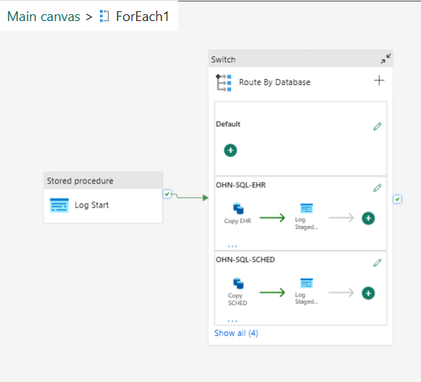
  - 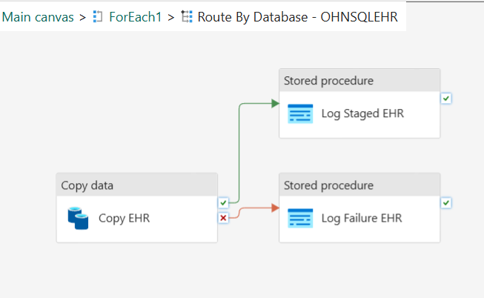
LogStart: Assign parameters and variables to start with data ingestion.
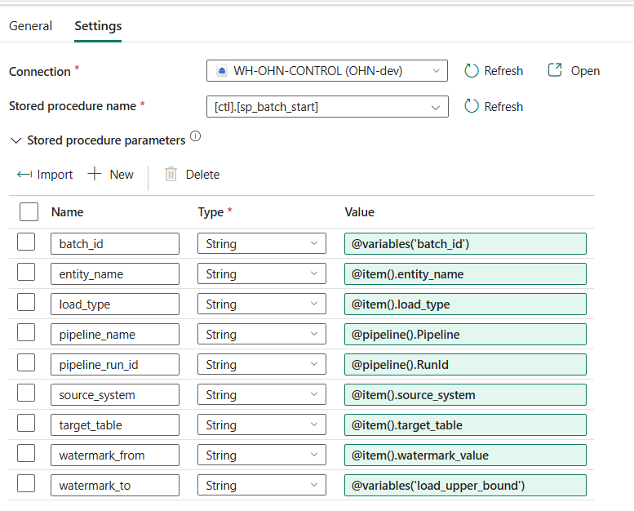
SwitchCase: Runs over the 3 databases
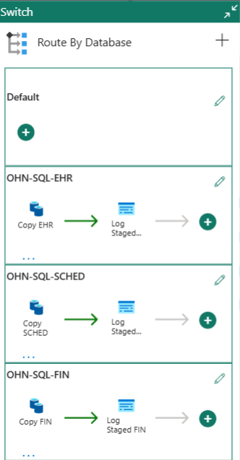
Inside 1 case: OHN-SL-HER
CopyActivity: getting data from Onprem SQL Server to LH_Bronze
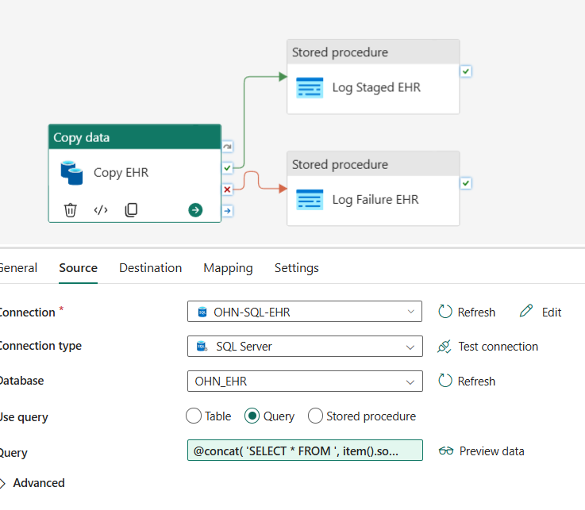
For this ingestion, I have been using Docker to setup SQLservar image to transfer data over localhost:1433. Using ‘On-Prem Datagateway’, I setup a gateway connection between localhost and my Fabric User account. One new connection has been assigned inside Fabric ‘Managed Connectiontions and Gateways’.
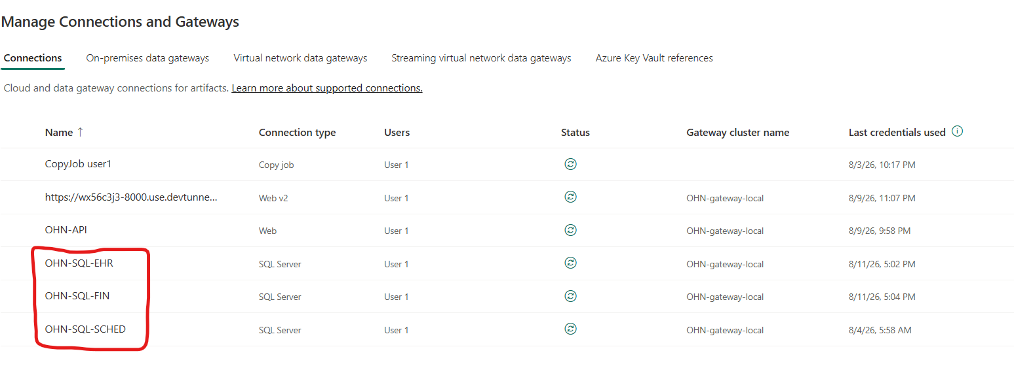
Query: @concat(
'SELECT * FROM ', item().source_object,
if(equals(item().load_type, 'incremental'),
concat(' WHERE ', item().watermark_column,
' > ''', item().watermark_value, '''',
' AND ', item().watermark_column,
' <= ''', variables('load_upper_bound'), ''''),
'')
)

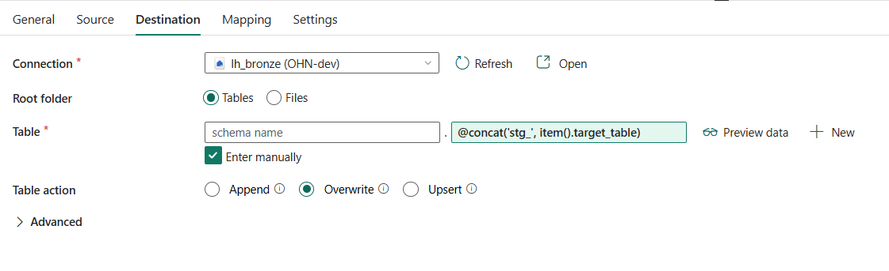
Source incoming data will be saved temporary named with prefix ‘STG’ with overwrite action. Since I am gonna push all these stagged table at last with the help of notebook, so overwrite action is being used for these intermediatory tables.
If Copy success, then it will be logges as success.
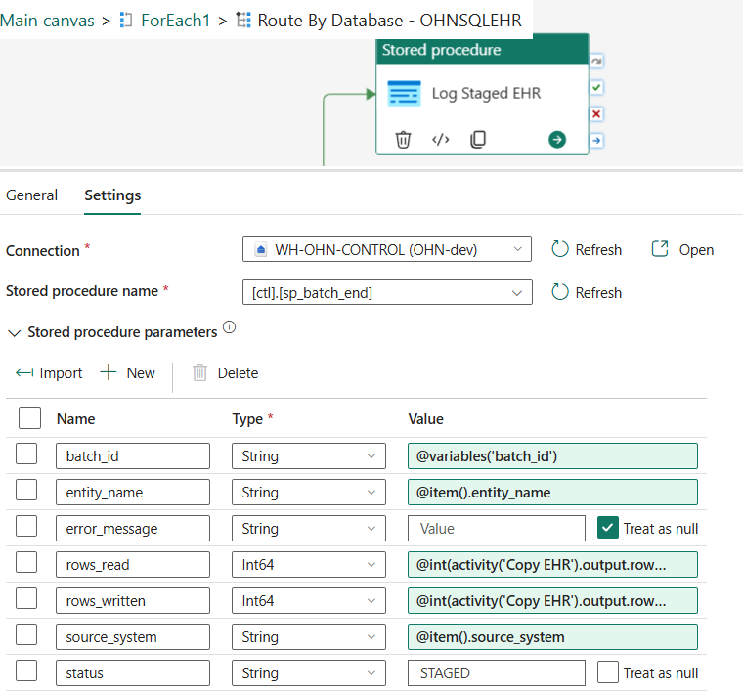
If fails
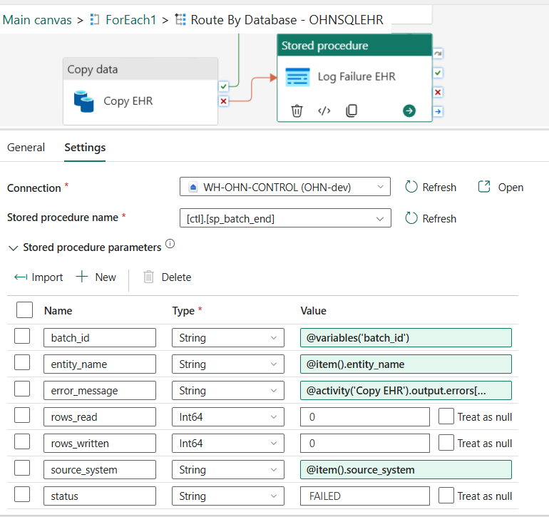
After success of forEach, we now have 11 staged tables ready to commit into bronze layer with additional appended columns with (batchID, watermark, etc)
Next -> Notebook Activty: Commit Staging with two base parameters batchID and ENTITIES.
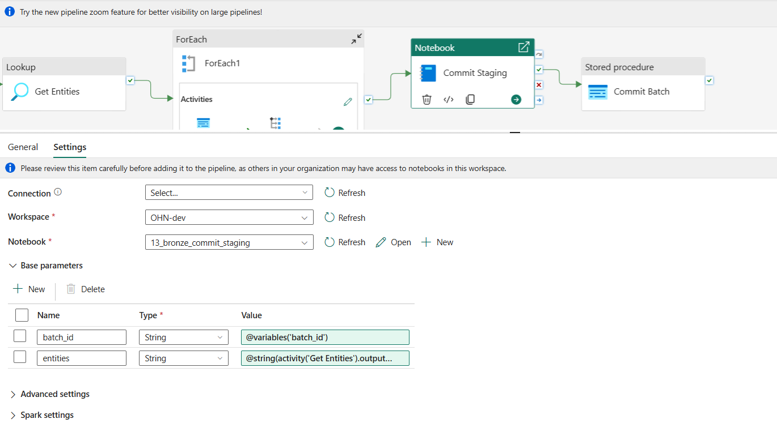
Notebook Snapshots:
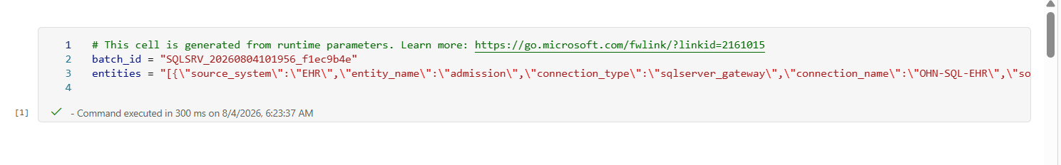
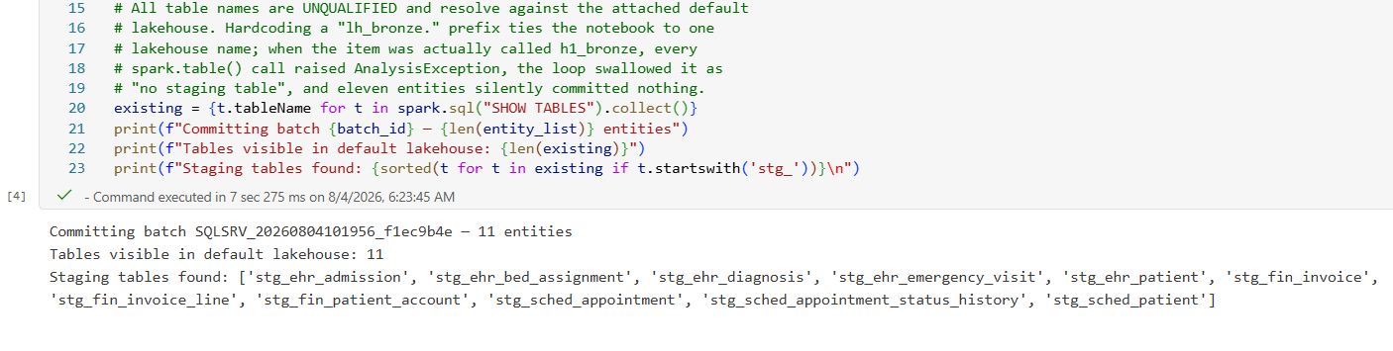
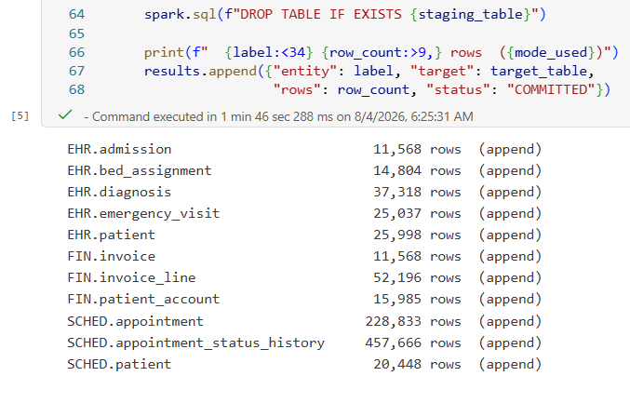
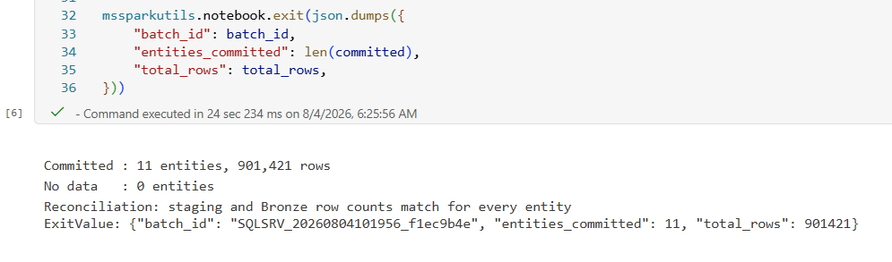
At Last, pipeline ended with Commit Stagged SP
